**GITHUB**

**AND**

**GIT**

**INDEX**

|  |  |  |
| --- | --- | --- |
| Sr.No | Topic | Page. No. |
| 1 | Index Page | 1 |
| 2 | Why to use GitHub | 2 |
| 3 | Git and GitHub Installation | 3 |
| 4 | Create Repository in GitHub | 5 |
| 5 | Host Repository in GitHub Pages | 7 |
| 6 | CMD basic terminal Commands | 9 |
| 7 | Git Login to GitHub Web | 10 |
| 8 | Folder upload via GIT | 11 |
| 9 | Git Commands | 10 |
| 10 | To Create Branch Via GIT | 15 |
| 11 | End Page | 16 |

**Why To use Git or GitHub in the first place?**

* "Git is like a time machine for computer files. It lets people save their work and go back to any point if they make a mistake. GitHub is like a big playground where people share their projects and play together, making it easier for everyone to help and have fun."
* If u and your friend living in another country or different place and u want to share code or work on same project but rather sharing code in some other platform in the manner of saving file, exporting, sharing to platform then your friend extracting, importing to his Code Space you can simply post on GitHub and see the work and work actively at the same time without repeating unnecessary steps.

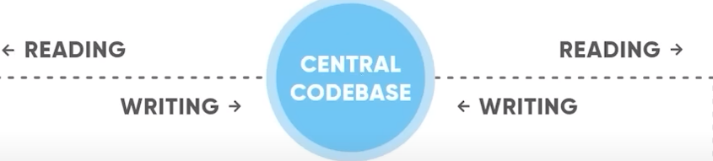

**Understand GitHub:**

* New Repository **(New Folder 📁)**
* History **(Versions)**
* Commit **(Save ✔)**
* Branches **(Work on same Project in different ways or by different people)**
* Fork **(Complete Copy 🧤)**
* GitHub issues section **(Complaint ⚠)**
* Command Line Interface **(GIT Software)**
* GitHub Pages **(Host Your static website in GitHub Itself)**

|  |  |
| --- | --- |
| Git | Github |
| Its management tool for our codespace. | Same Git Features and functionalities but just it’s in website Mode |
| Its Software | Its website |
| It works on command line. | It can work on any browser and it has GUI. |

**GitHub and Git Installation**

Git Install: <https://git-scm.com/downloads>

Download According to your System.

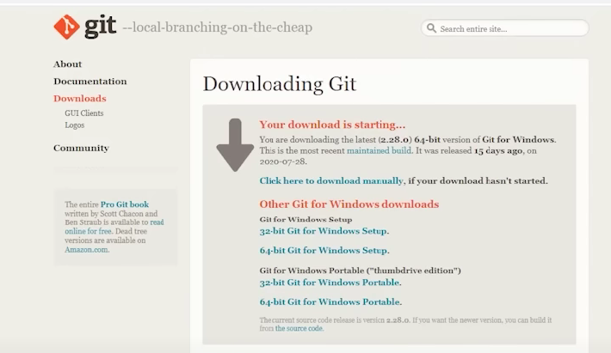

Steps For Installation:

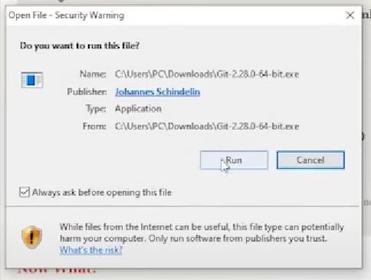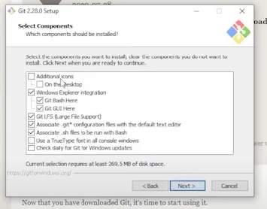

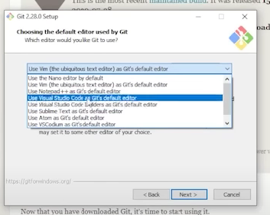

And rest choose default option only don’t change unless u know and install the app on your system.

After downloading git,

Open CMD and write git In it. (If git is installed your screen appears like this.)

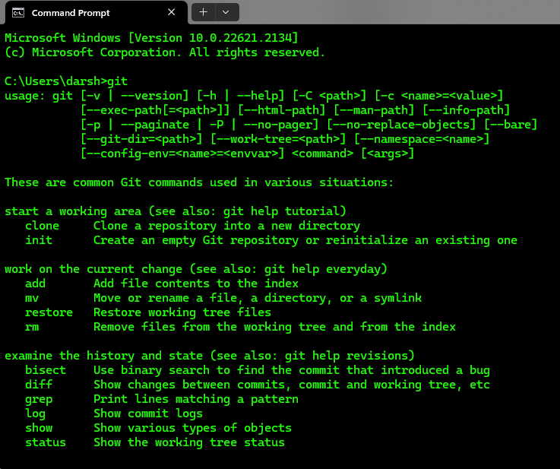

go to [GitHub](https://github.com/signup?ref_cta=Sign+up&ref_loc=header+logged+out&ref_page=%2F&source=header-home) & create your account :

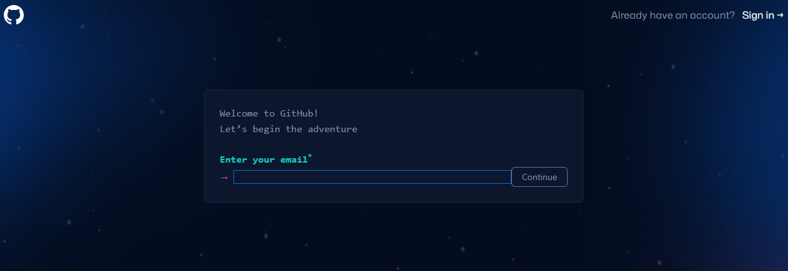

I Hope you have fulfilled the need now Go

Now, you can start with **Git** & **GitHub**.

Go to GitHub website for final upload to directory:

In your profile, go to new>create new repository>

There are 2 Option to make Private or Public so if the repository is private then only you can see and not others and for public its Vice versa.

You can create README file for your repository as it helps other to understands what you are doing.

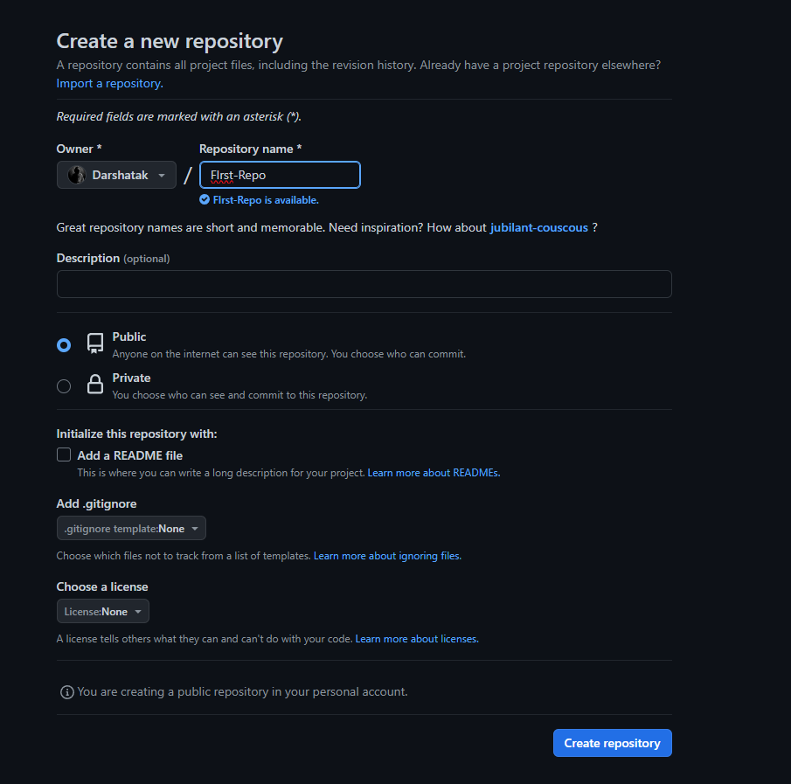

Click on Create repository:

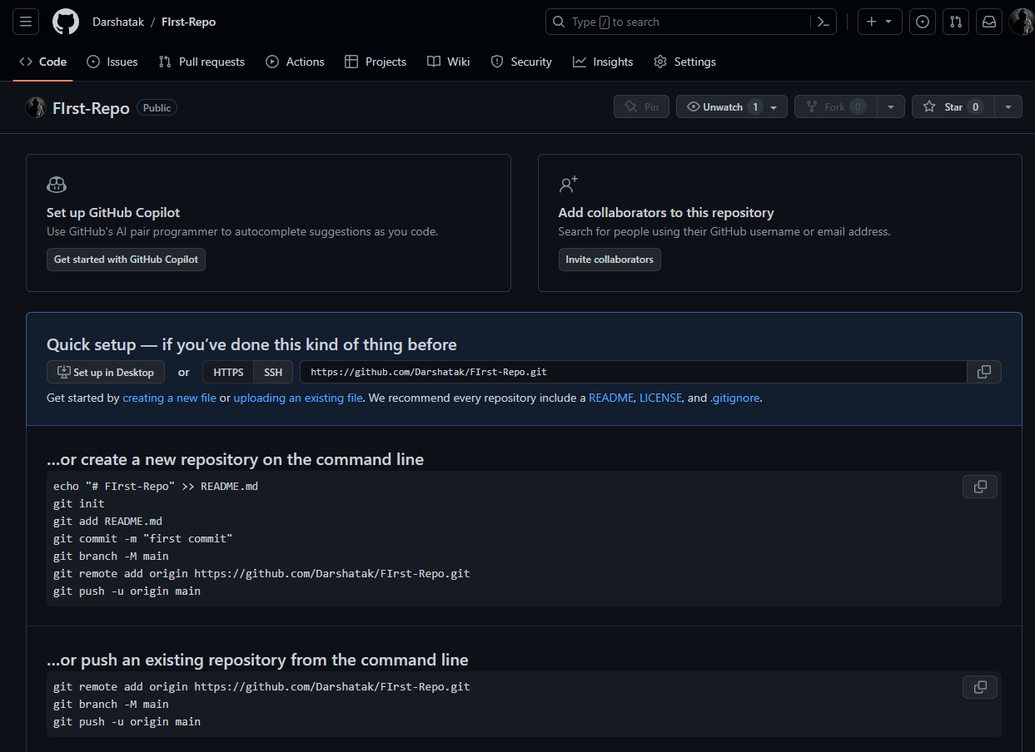

Now you can add or upload files in Github.

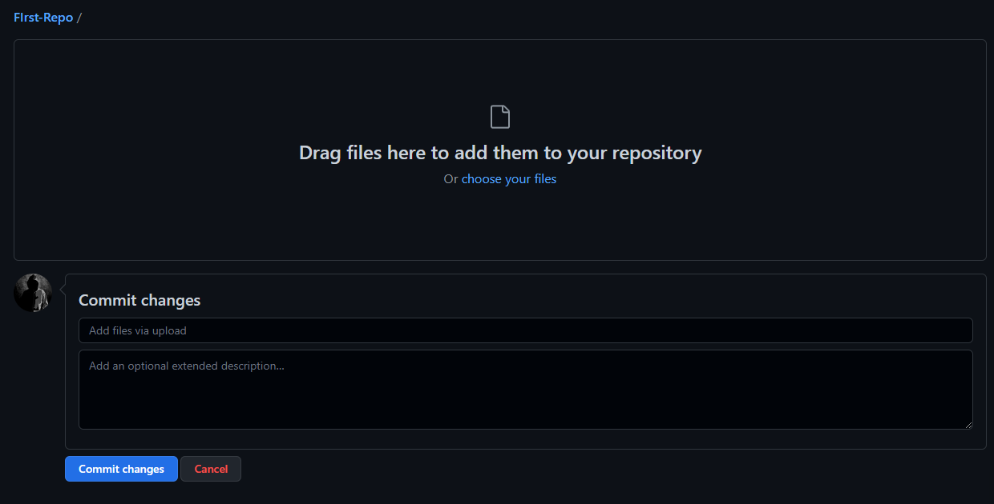

Upload has been done , Now Commit Changes

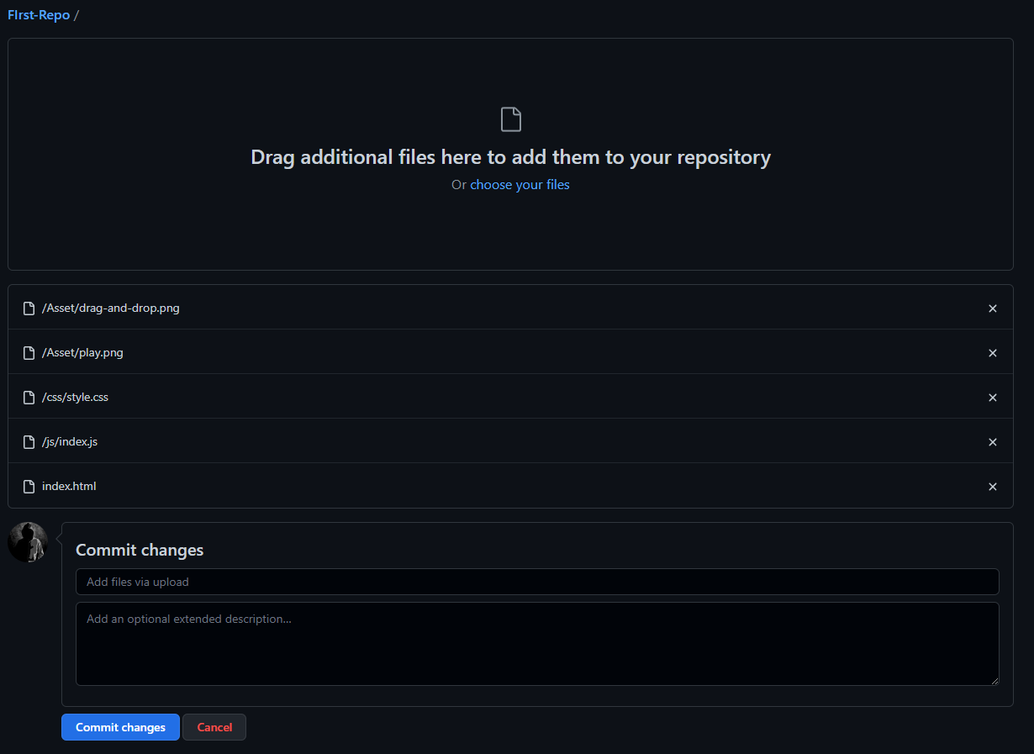

Now we will host your files in github pages.

Follow Steps:

1. Go to settings
2. Open Pages Section.
3. On Branch section select Main Branch and click save.

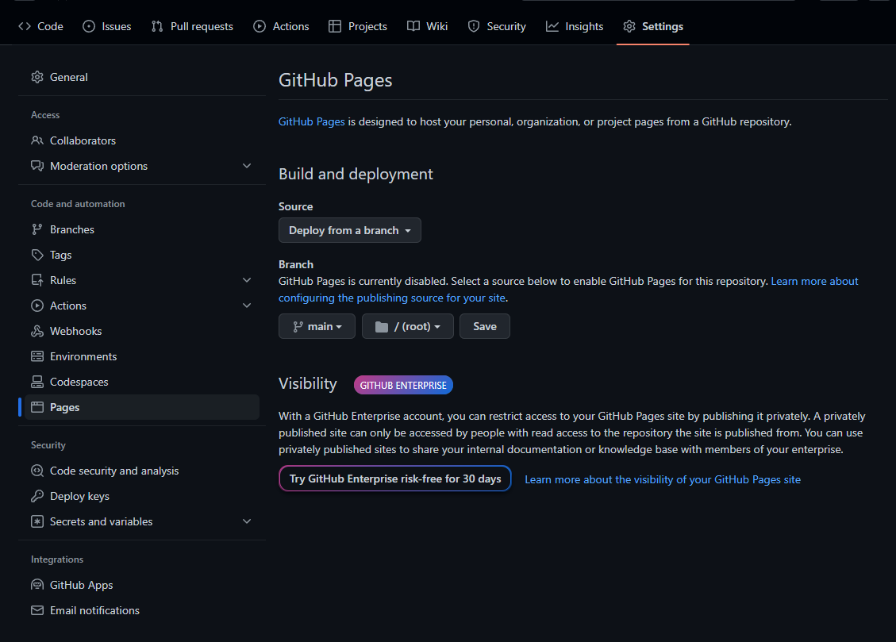

Now, Go to Actions and see the uploading process

Once the process is done u will get link of your uploaded repository.

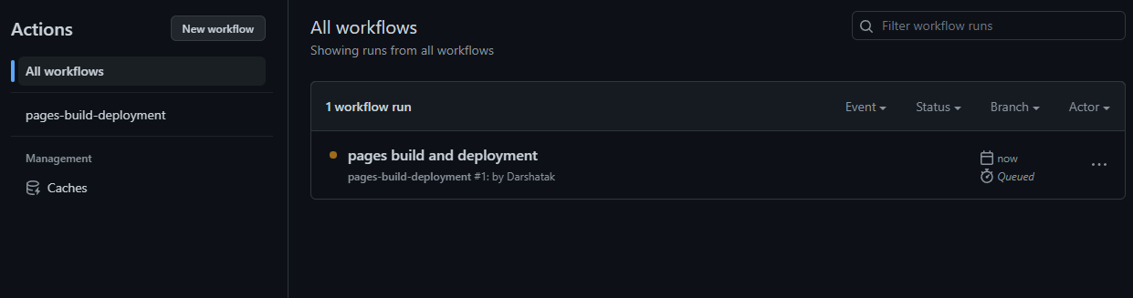

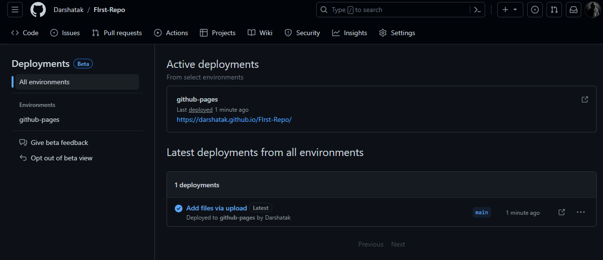

**GIT**

**CMD basic terminal Commands:**

**ls/dir**: list directory

**cls**: clear screen

**cd** : change/open directory

**cd ../ :** go back to previous folder

**Git initials:**

Whenever you push your code, git doesn’t remember who you are? So we have to let Git know who you are and what’s your email ID. So we have to initialize our Git by:

git config –global user.name “some name” (here global means this pc or desktop)

git config –gloal user.email “some email ”

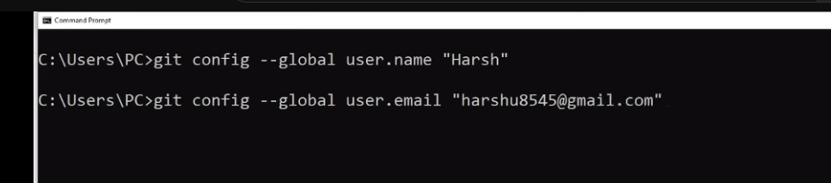

**Movie climax:**

So after creating a new repository, while inserting a folder of your need, you need to open the folder path in cmd terminal and you need to use all the commands given below for Git push initialization.

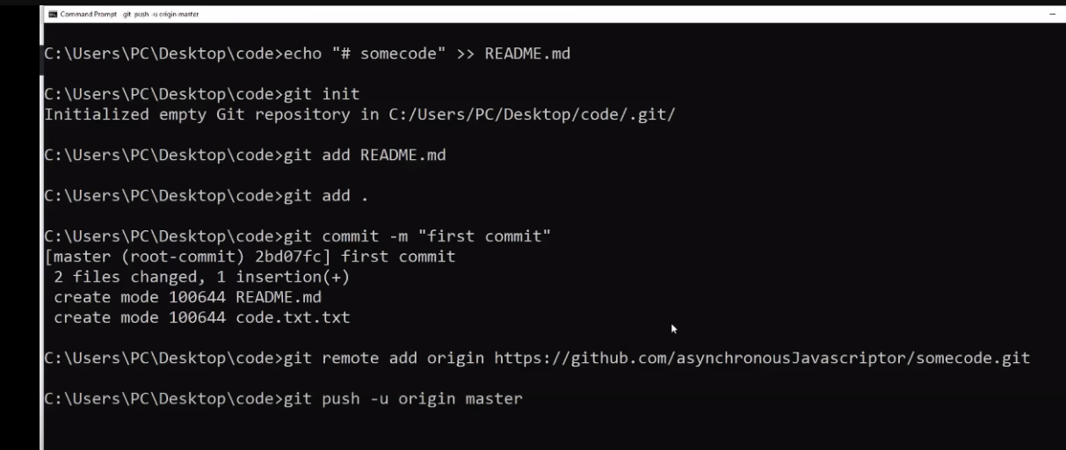

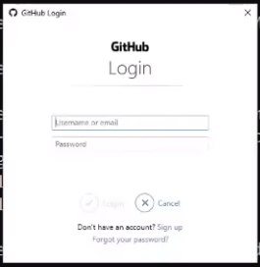

After login password, your code or folder will be started with uploading process and show you uploaded confirmation as below:

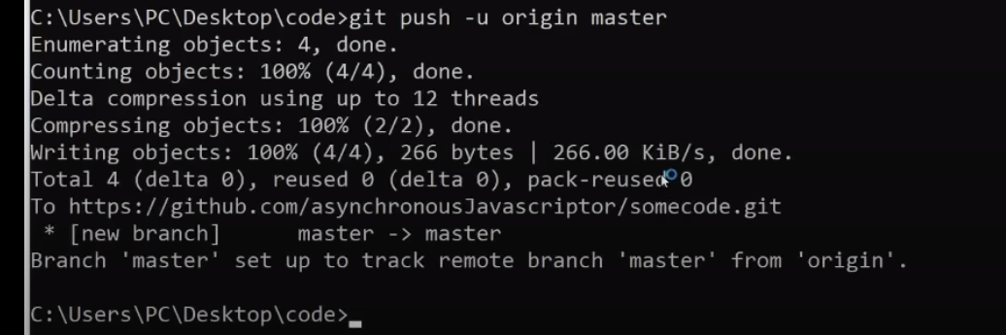

**Commands:**

git init, git status, .gitignore

difference between working area, staging area, & get directory

git add ., git reset, git reset fname

git commit – m “some message”

**To understand how any folder gets uploaded to GitHub:**

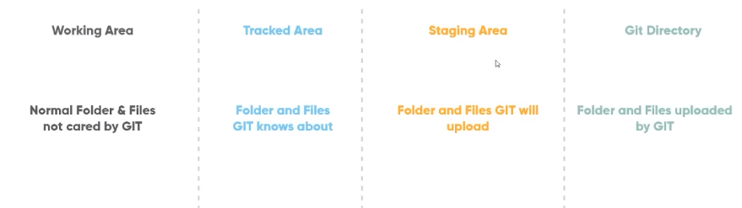

Example for Working Area or Untracked Area:

Open path folder that you want to upload to GitHub…> git init

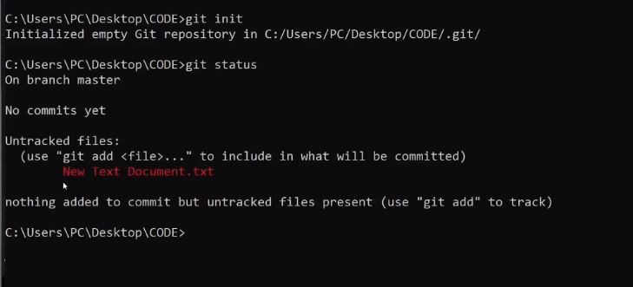

Taking untracked files to Tracked Area: git add .

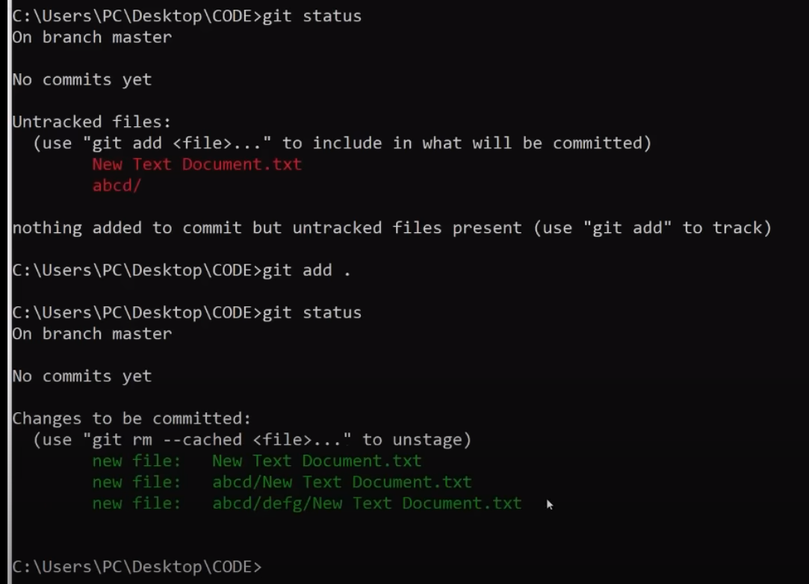

Now, taking tracked files to Staging Area: git commit –m “some message”

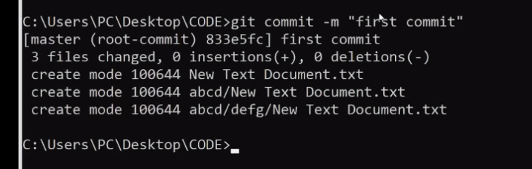

Now the final step

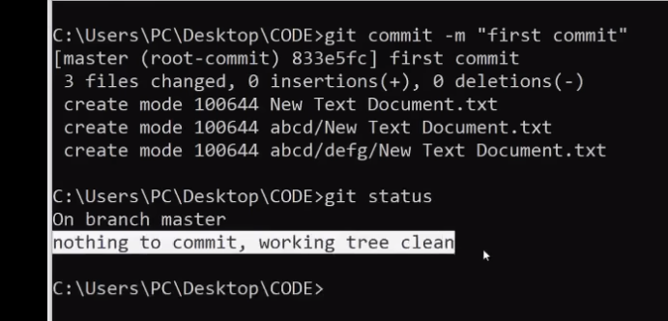

git remote add origin https://github.com/.............dir_name.git

git push –u origin master

Here the master is the default branch for a directory.

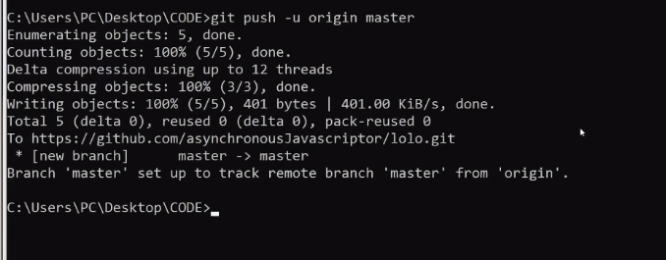

Your folder is completely uploaded on desired directory of GitHub.

**Git commands:**

**git init 🡪**

Allows you to run any git commands on that folder.

(Initializing the git in the specific folder, or giving access to Git for that folder)

**git add . 🡪**

Adds every file in git’s tracking area.

**git commit – m “some message” 🡪**

Stage the files to get pushed on next push command

**.gitignore 🡪**

A file used to ignore the files which you don’t want to get track of, by git. (We can do it by creating a file as “.gitignore” and under that file just type the names of file that you want git to ignore e.g. “index.html” for one file. For multiple files with same extension, “*.html”)

**git status 🡪**

Shows the current tracked & untracked files. (For checking the status of folders or files that are uploaded or not uploaded the current folder you want to push)

**git reset 🡪**

Makes all file untracked that are already tracked.

**git log 🡪**

Shows the hash code and details about the recent commit.

**git remote 🡪**

Setting address of the location where the changes will be pushed to

**git clone 🡪**

Clones/copies the git files from the internet to your computer (just after the command typed on cmd git clone URL. Here, URL is for the code that you want to copy from GitHub)

Situation:

if a folder is already uploaded on GitHub. But you made some changes on that file in your pc and not on GitHub repository. Then,

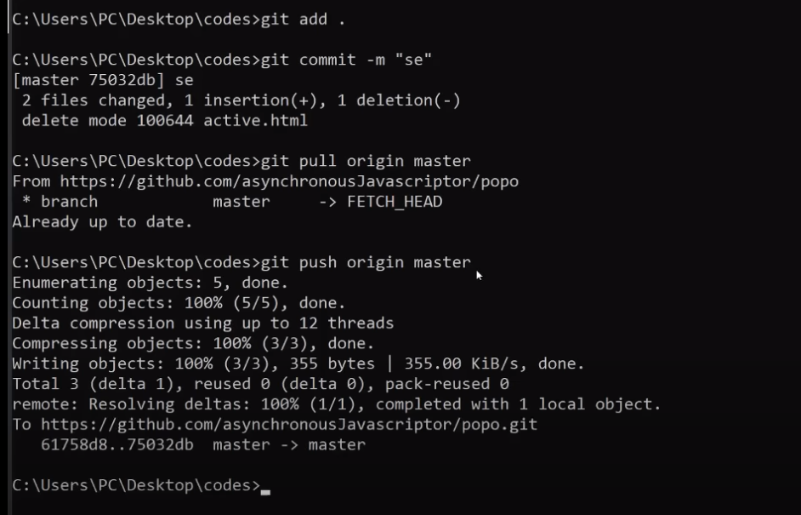

if there is an error on pull origin master command, then just give directory or repository address of that folder where you before committed.

git remote add origin https://github.com/.............dir_name.git

Situation:

To create branch: git branch branch_name

Changing branches

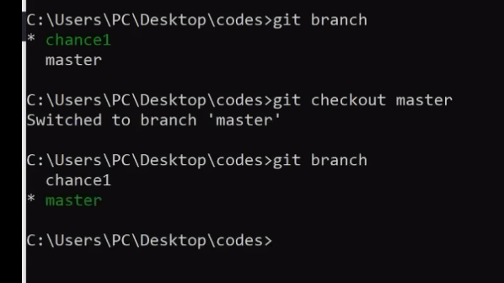

Merging Branch to Master:

